TITLE - TIMES NEW ROMAN (TNR), 14 point,

black, bold, all caps, centered

Author – Times New Roman 12 pt. black centered
Author Organization, City, State ZIP, and Country – Times New Roman 12 pt. black centered

Author email –Times New Roman 12 pt. black centered

- Heading – Times New Roman, 12 pt., bold, numbered, left-aligned
MORIS (Magnetics and Optics Research International Symposium) will be provided for all researchers and engineers who are interested in new technologies for future data storage. MORIS gives a good opportunity for fruitful discussions about not only the basic research of thermal, magnetic, and optical physics, but also the recent applications such as spintronics, nano-fabrication technologies, and novel optical/magnetic materials.

- Heading
Instructions: Abstracts must be written in English and follow these guidelines: Limit the length of the abstract to two pages, including figures, tables, results, discussion, and references. Include the entire abstract within a 17 cm. x 22 cm. rectangular area for offset reproduction on A4-size paper. Save the abstract in Portable Document Format (as a .pdf file). Submit the file online by February 26, 2022. The website will not accept abstracts after the deadline. DO NOT send abstracts to the conference secretariat directly. References should be formatted and styled in this manner [1]. This is an example of an acceptable reference [2, 3].

- Heading
The text in these paragraphs should be formatted in Times New Roman, 12 pt., black, justified. The titles of figures, tables, and photographs should use 12-point font in the main body. For captions and legends, the font size should be 12 points, and the caption headings should be in bold font, as in “Fig. 1”. The titles of the reference’s sections should not include a section number. Please be sure that the formatting matches the examples given in this document.
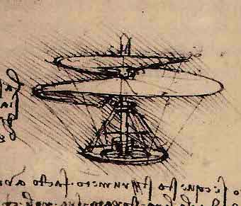

Fig.1 Figure caption: Times New Roman, 12 pt.

- Heading
Please notice that your abstract will be printed in black and white. Abstracts will be selected on the basis of their originality and the significance of the results. If an abstract is accepted, it will appear in the Technical Digests distributed at the symposium.
Authors of papers accepted in MORIS 2022 are encouraged to submit the original and significant part of the papers to the Special Issue of the Japanese Journal of Applied Physics (JJAP), which will be published in March 2023. The deadline of the paper submission is June 30, 2022. Those who wish to submit a paper to the special issue should follow the instructions for preparation of manuscript for JJAP. Please note that the manuscript will be published after the usual review process in JJAP. The special issue is not just proceedings of MORIS 2022.

References
- Names of the authors: Name of the journal, Volume of the journal, page (year of publication).
- Names of the authors: Name of the book, Editors' names, page (publisher, place of publication, year of publication).
- Names of the authors: Name of proceedings, Name of conference, Name of the editor, Place of conference, year of conference, page (publisher, place of publication, year of publication).

